# Service Proposal

December 20, 2023

Prepared Exclusively For:

Prepared By:

.

**Business Name (EasyDocs Testing)**

**Aiden Carnegie**

**6477082392**

**mohammedo@wingmateapp.com**

**Mohammed Osumah (Wingmate)**

**Metropolitan** has been Family-owned and operated Since ***1982***

Metropolitan Linen Services is a family owned and operated business with over 40 years of experience in the uniform and linen rental industry. We are a primary service provider to hospitality and commercial companies throughout New England.

We are proud to say even with our rapid growth and success we have continued to keep a *close, personal relationship* with each and every customer.

**Today, the company reaches five states (Massachusetts, New Hampshire, Connecticut, Rhode Island and Maine) in the New England region.**

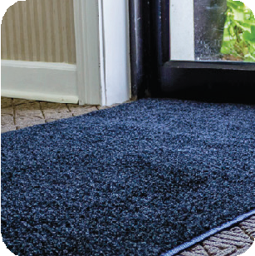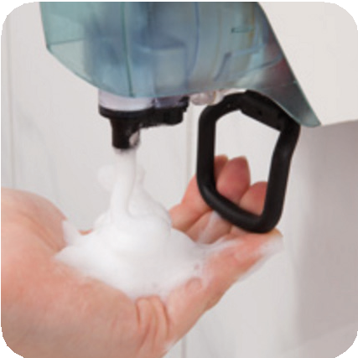

**Our** Services

We provide a comprehensive range of services aimed at enhancing cleanliness, hygiene, and professional appearance for businesses and individuals alike.

We specialize in:

* **UNIFORMS - DUST CONTROL**
* **LINEN - RESTROOM SERVICES**

**UNIFORMS LINEN DUST CONTROL RESTROOM SERVICES**

105 Ward Hill Avenue, Haverhill, MA 01835 | 617.381.1156 | [customerservices@metropolitanlinen.com](mailto:customerservices@metropolitanlinen.com)

**metropolitanlinen.com**



# Service Summary

Frequency of Delivery: Multiple Per Week

Table Linen

|  |  |  |  |  |  |  |
| --- | --- | --- | --- | --- | --- | --- |
| **SKU** | **Product** | **Qty** | **ARC** | **Inv** | **Unit Price** | **Weekly Rental** |
| **12001** | WHITE NAPKIN | 100 | $3.10 | 1000 | $0.09 | $8.50 |
| **11202** | 120" IVORY ROUND TC | 200 | - | 2000 | $6.00 | $1200.00 |
| **11202** | 120" IVORY ROUND TC | - | - | 1000 | $6.00 | - |
| **11261** | 126" WHITE ROUND TC | 2 | - | 10 | $6.00 | $12.00 |
| **11202** | 120" IVORY ROUND TC | - | - | 100 | $6.00 | - |
| **Subtotal Total:** | | | **$3.10** | **Maintenance (15%)** | | **$1403.57** |

Uniforms

|  |  |  |  |  |  |  |  |
| --- | --- | --- | --- | --- | --- | --- | --- |
| **SKU** | **Product** | **Size** | **Qty** | | **Inv** | **Unit Price** | **Weekly Rental** |
| **22102** | AMBER BISTRO APRON W/ POCKET | M | 20 | | 2000 | $0.75 | $15.00 |
| **22102** | AMBER BISTRO APRON W/ POCKET | S | 10 | | 10 | $0.75 | $7.50 |
| **21004** | NAVY BLUE BIB APRON | N/A | 5 | | 10 | $0.36 | $1.80 |
| **Subtotal Total:** | | | | **Maintenance (30%)** | | | **$31.59** |

Mats, Mops and Towels

|  |  |  |  |  |  |  |
| --- | --- | --- | --- | --- | --- | --- |
| **SKU** | **Product** | **Qty** | **ARC** | **Inv** | **Unit Price** | **Weekly Rental** |
| **31001** | KITCHEN TOWEL | 2000 | $62.00 | 2000 | $0.15 | $300.00 |
| **31101** | BAR MOP | 5 | $1.55 | 10 | $0.15 | $0.75 |
| **50001** | LAUNDRY BAG | 5 | - | 10 | $0.35 | $1.75 |
| **41201** | BATH TOWEL | 1 | - | 1 | $0.60 | $0.60 |
| **60001** | AIR FRESHENER DISPENSER | 20 | - | 2000 | $2.00 | $40.00 |
| **Subtotal Total:** | | | **$63.55** |  | | **$343.10** |

Ancillary

|  |  |  |  |  |  |
| --- | --- | --- | --- | --- | --- |
| **SKU** | **Product** | **Qty** | **Inv** | **Unit Price** | **Weekly Rental** |
| **50003** | BAG STAND | 1 | 2 | $0.00 | $0.00 |
| **50012** | DUST MOP HANDLE | 10 | 20 | $0.00 | $0.00 |
| **Subtotal Total:** | | | | | **$0.00** |

**DEFE (6%): $110.69**



**Estimated Cost: $1955.61**

*\*\*DEFE: Delivery, environmental, Fuel and Energy charge*

*\*ARC: Automatic Replacement Cost*







**metropolitanlinen.com**